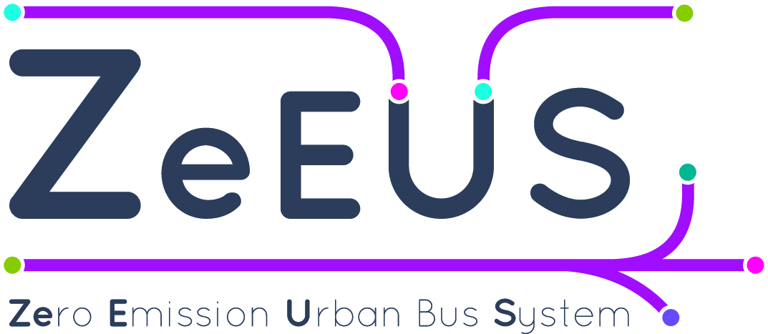
Bringing electrification to the heart of the urban bus network
Coordinated by UITP, ZeEUS is a flagship electro-mobility project bringing together 40 partners representing the whole value chain of stakeholders: public transport authorities and operators, bus manufacturers, industry suppliers, energy providers, national and international associations, research centres and consultancies.
4 KEY OBJECTIVES:
- Extend the fully-electric solution to the core part of the urban bus network composed of standard 12-metres and double-decker buses
- Evaluate the economic, environmental and societal feasibility of electric urban bus systems through live operational scenarios across Europe
- Facilitate the market uptake of electric buses in Europe with dedicated support tools and actions
- Support decision-makers with guidelines and tools on “if”, “how” and “when” to introduce electric buses
(Pictures of the 6 buses to be included somewhere on the flyer /Photos des 6 bus à inclure quelque part sur la plaquette)

Innovative electric bus solutions including plug-in hybrid, full battery electric and trolley bus technologies combined with different charging infrastructure modes will be demonstrated on standard 12-metres and double-decker buses in real operational scenarios in 8 European cities: Barcelona (Spain), Bonn (Germany), Cagliari (Italy), Glasgow (UK), London (UK), Münster (Germany), Plzen (Czech Republic) and Stockholm (Sweden): (put the city names on the map / metre le nom des villes sur la carte directement)

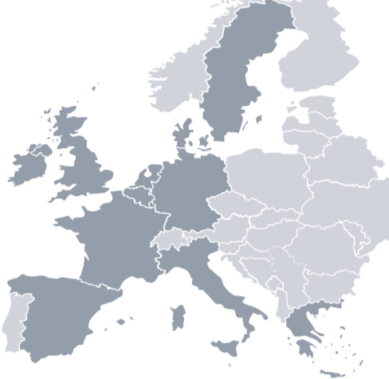

MAP CAPTION:
8 core demonstrations in 6 European countries with:
- 35 standard 12-metre and double-decker buses
- 3 innovative electric solutions: plug-in hybrid, full battery electric and trolley buses
- 4 energy supply modes: plug-in, conductive, inductive, overhead line
- 3 fast and slow charging strategies: overnight, terminals, opportunity

An Observatory will be established to closely follow and discuss the progress of urban bus system electrification around the globe and will contribute to its deployment strategies. Selected observed and monitored demonstrations will join the ZeEUS network. ZeEUS will also encourage collaboration beyond boundaries by establishing key relationships between similar projects and initiatives in the field of electro-mobility through its networking activities.

ZeEUS in brief
Scope: Testing electrification solutions at the heart of the urban bus system network through live urban demonstrations and facilitating the market uptake of electric buses in Europe.
Duration: Nov 2013 – April 2017 [42 Months]
Budget: 22.5m EUR (13.5 EU Funding)
Coordinator: UITP, the International Association of Public Transport
40 Partners:

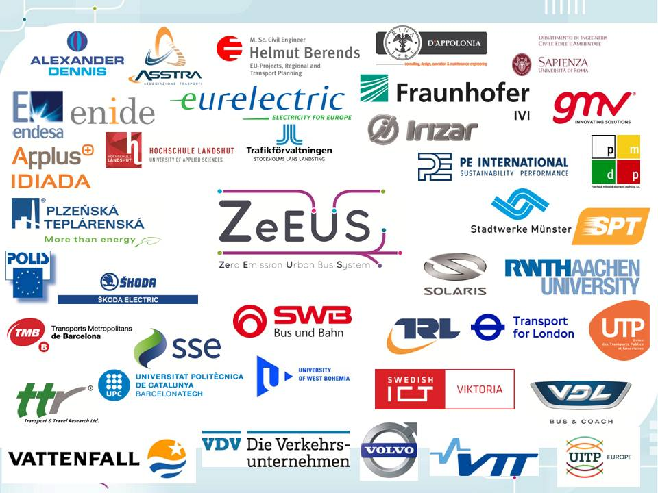

www.zeeus.eu

Contact:
Stephanie Leonard, Junior Project Manager
stephanie.leonard@uitp.org
UITP
Rue Sainte-Marie 6
B-1080 Brussels
www.uitp.org

Follow ZeEUS on (Facebook logo), (Twitter logo) & (Linkedin logo)

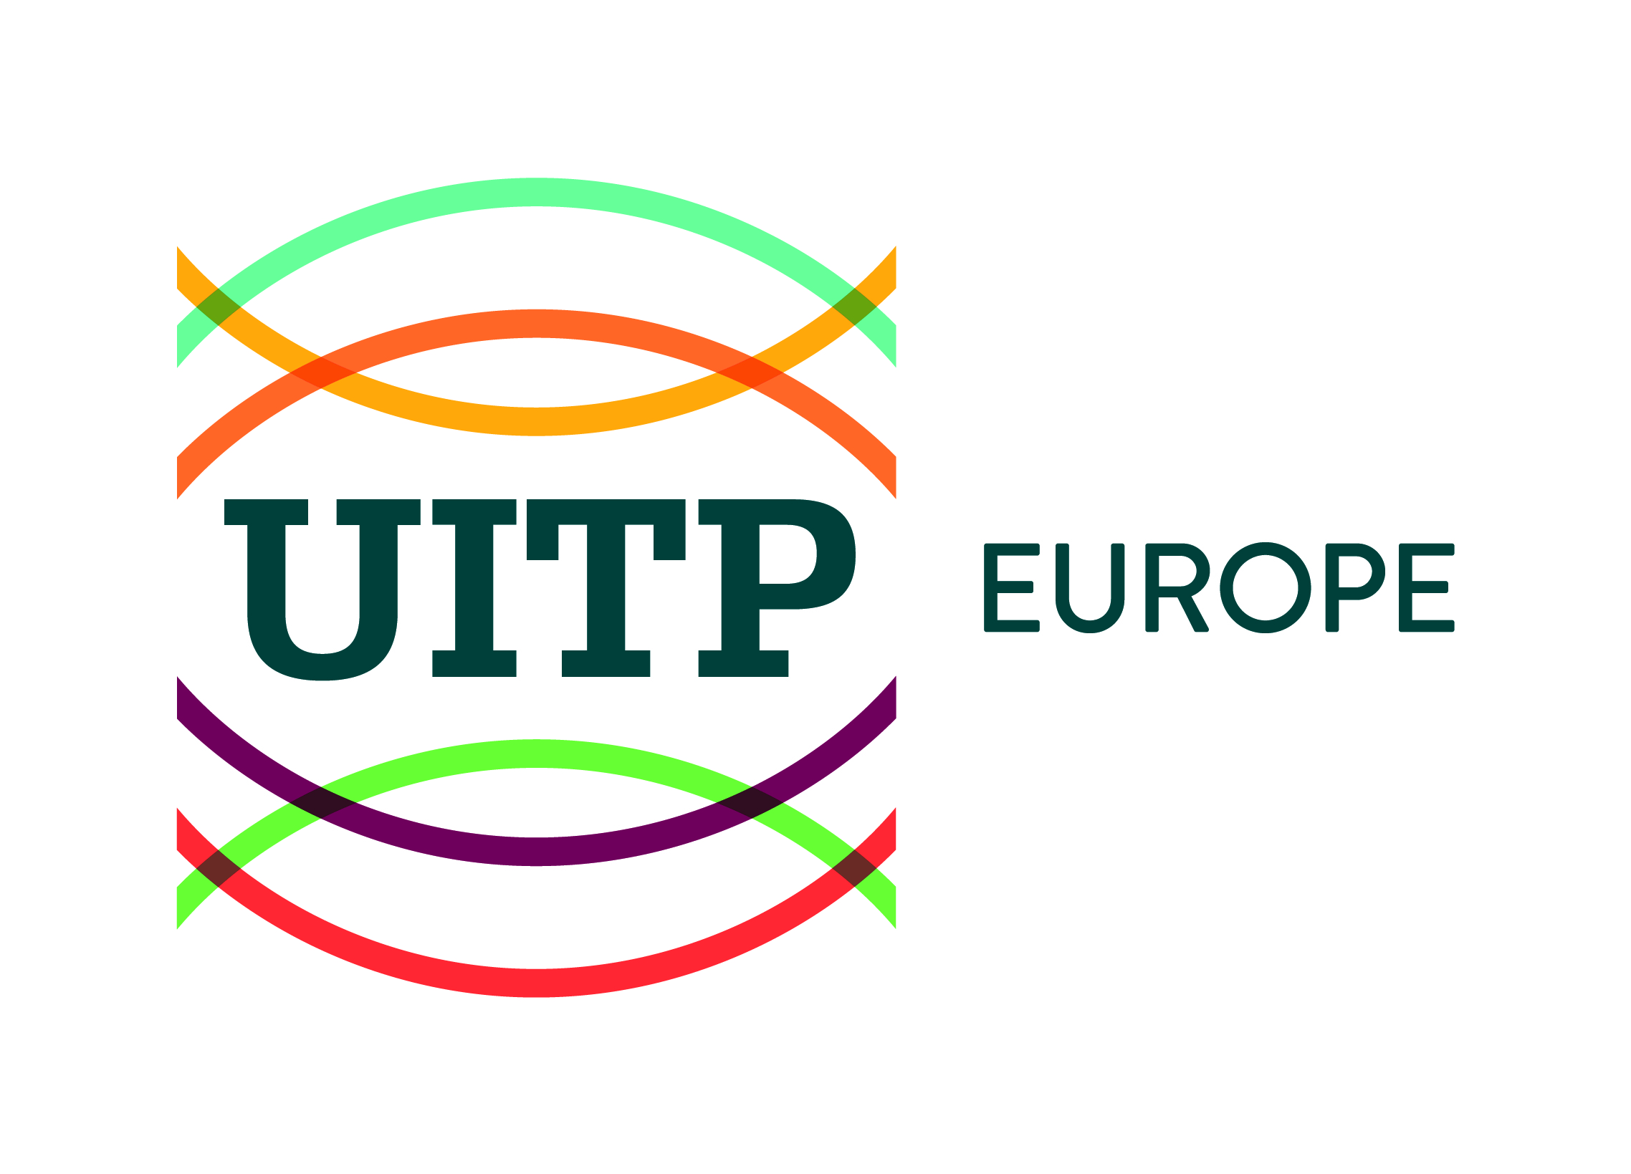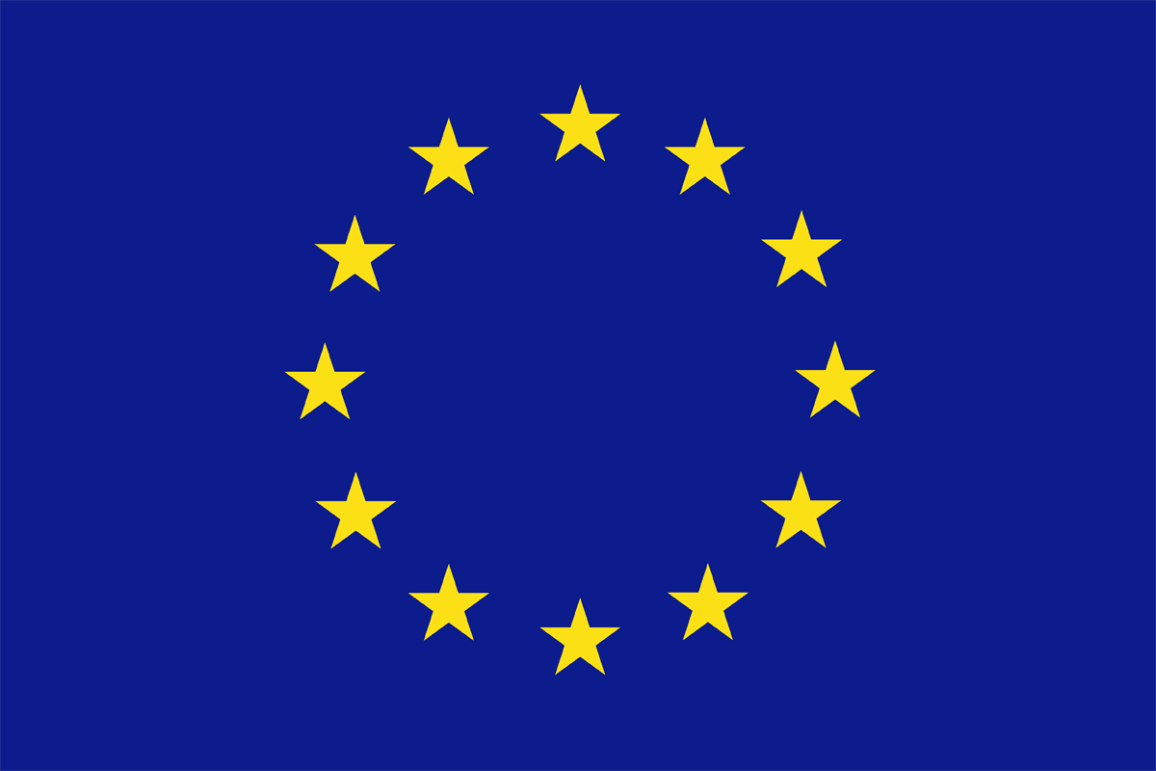
Coordinated by UITP, ZeEUS is co-funded by the European Commission under the 7th Research & Innovation Framework Programme, Mobility & Transport Directorate General under grant agreement n°605485. The ZeEUS project has been launched by the European Commission in the frame of the European Green Vehicle and Smart Cities & Communities Initiative.

